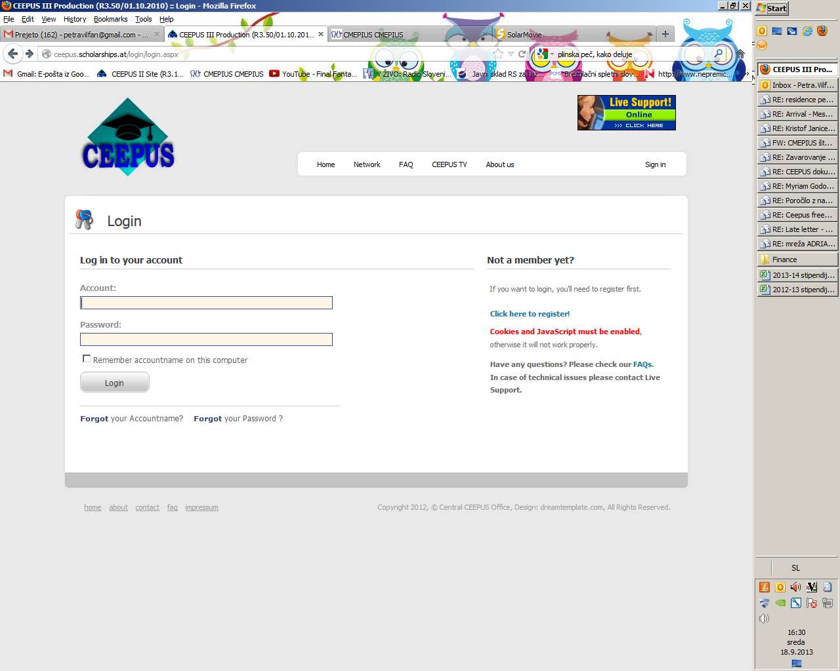

If you haven't registered yet, please register first.

Next time, you simply sign in – do not register again.

Please note your username and password as you will need them again in the next days + after the excursion + for your next CEEPUS exchanges.

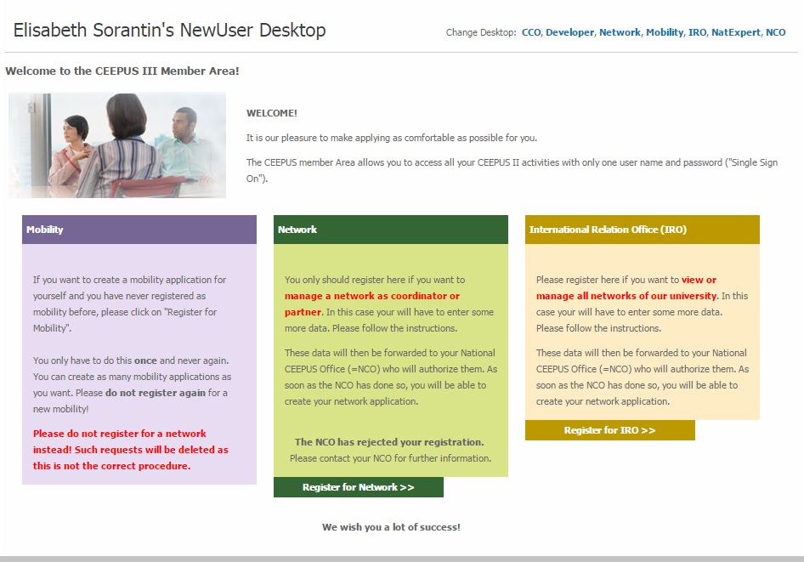

Click here to register = to create your username and password.

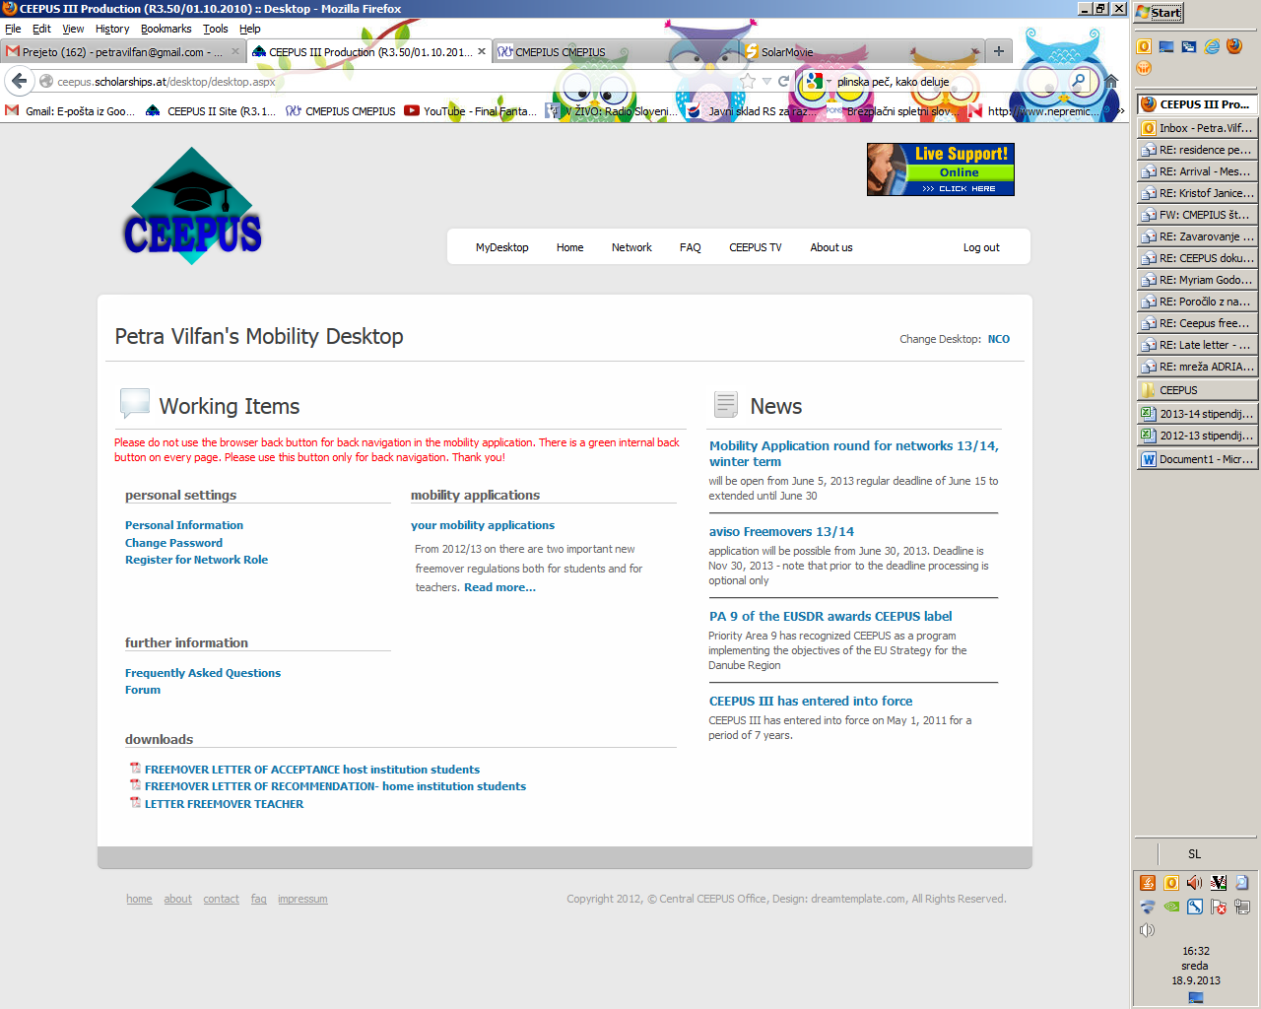

Click on ***your mobility application***

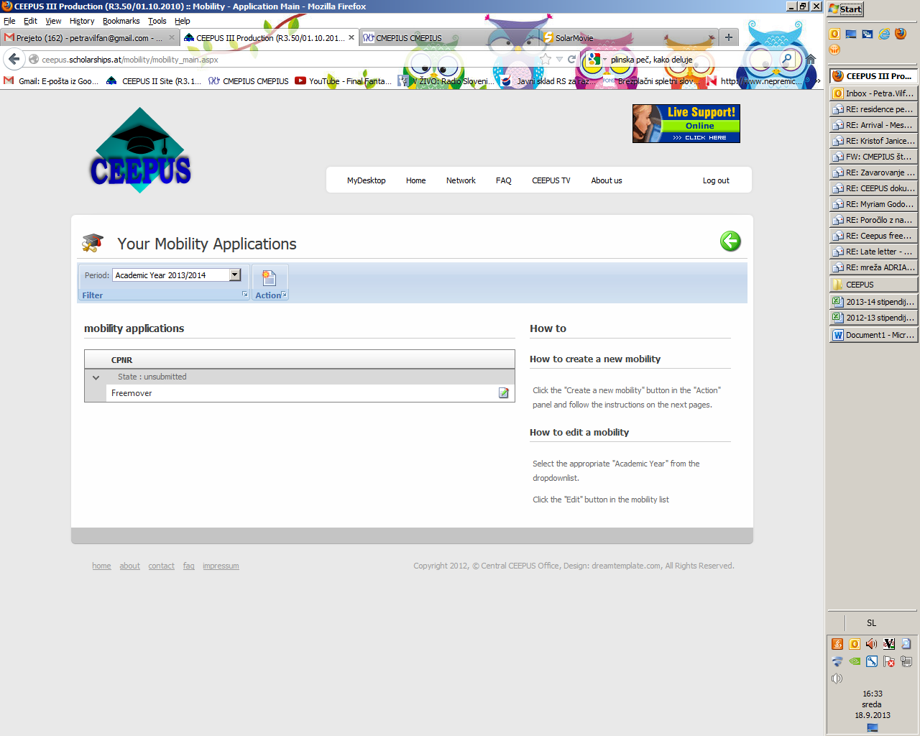

Select the academic year 2019/20

& click on ***Action***

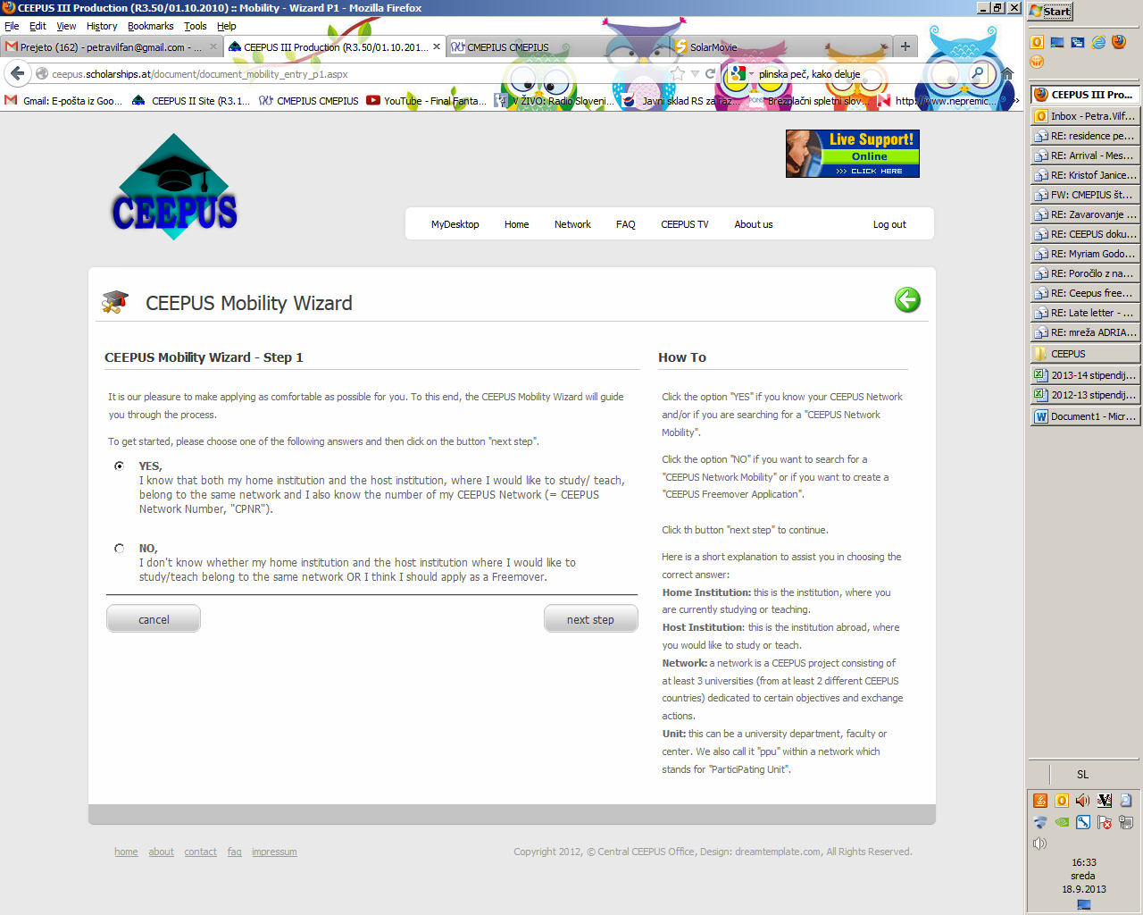

Select »Yes« and perform the following actions.

Please select the network CIII-AT-1101-04-1920

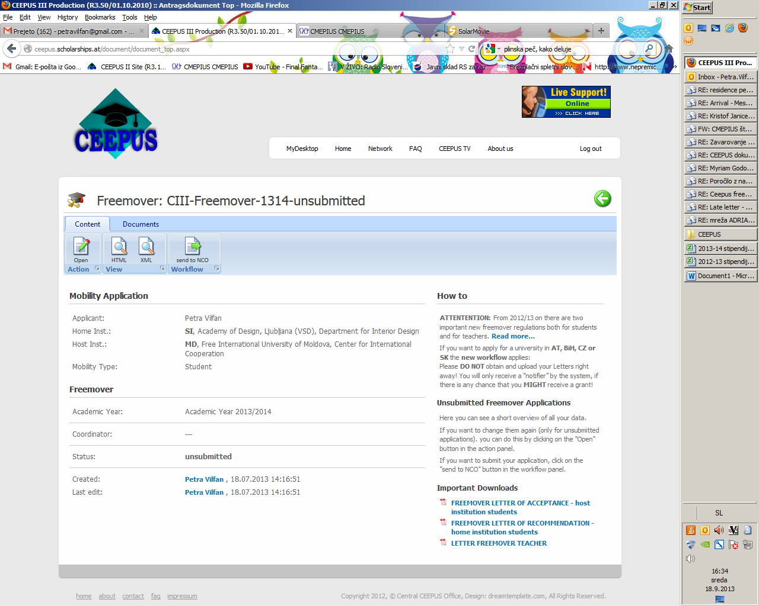

Clik on »Open« and check which data are missing.

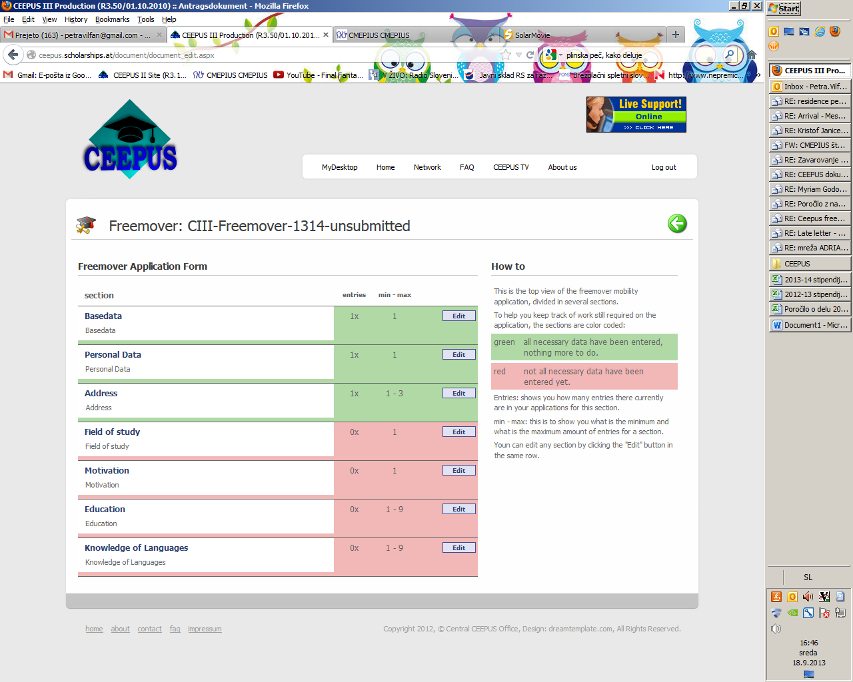

You will be able to submit your application, when all lines are green.

**When all lines are green, click on the white arrow in the green circle (upper right corner)**



**Submit your applicationi by clickinig on the button »Send to NCO« or »Send to PPU«.**

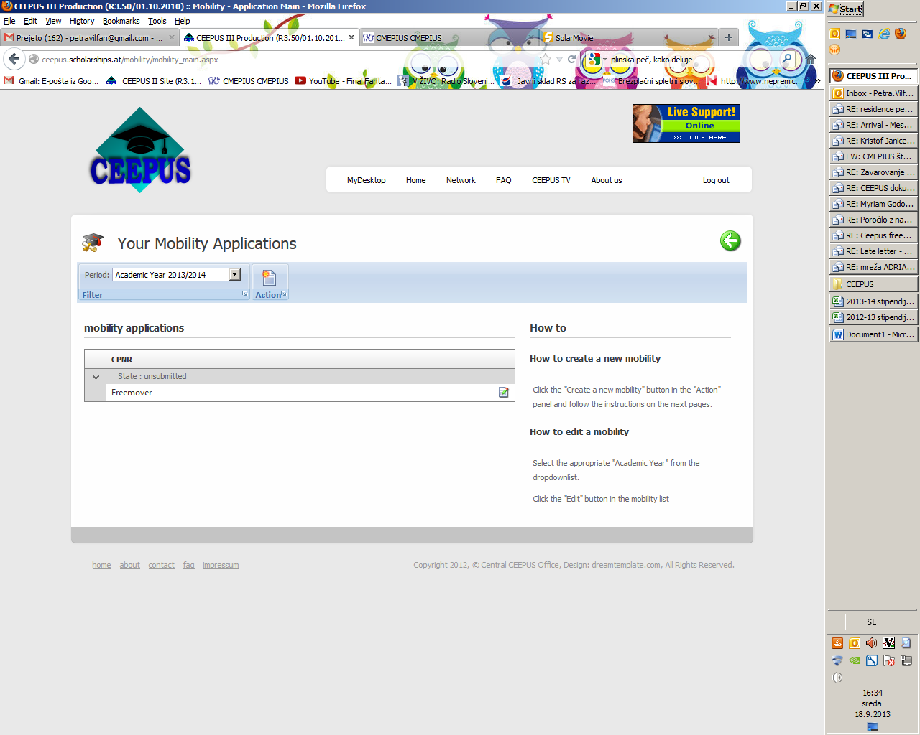

By signing in to the system you can check how the status of your application will be changing in the next days.