

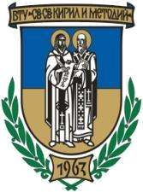
ST. CYRIL AND ST. METHODIUS UNIVERSITY OF VELIKO TARNOVO BULGARIA


FACULTY OF HISTORY
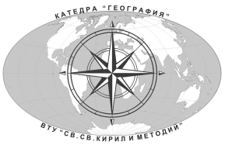

DEPARTMENT OF GEOGRAPHY

for participation in INTERNATIONAL SCIENTIFIC CONFERENCE
„GEOGRAPHY, GEOPOLITICS AND SOCIAL DEVELOPMENT”
in honour of the 60th anniversary of Prof. Dr. Habil. Atanas Dermendzhiev

Name, surname: …………………………………………………………..……………………………………………………………
Scientific degree and title: …………………………………………………………………………………………………………
Name and address of the institution, you work in: ……………………..…………….…………………………….…
Correspondence address, phone number, e-mail: ……………….……………………………………………………..
Title of the research in English:
- …………………………………………………………………………..……………………………………………………...……
Abstract of the research in English (in brief):
- …………………………………..……………………………………………………………………………………………...……

Please, send your application form no later than 17.09.2020
at e-mail: geo2020vtu@gmail.com


5003 Veliko Tarnovo, Bulgaria, 2 “T. Tarnovski” str.
St. Cyril and St. Methodius University of Veliko Tarnovo
e-mail: geo2020vtu@gmail.com

